The Haircare Market 3 Day Tournament
Ngaaruawaahia Golf Club
October 24th – October 26th

We had a great field of 84 players from 22 different golf clubs.
There were three divisions, one Women and two Men’s
The tournament format was Gross, Nett and Stapleford event.
The weather was a mixed bag, Day one was fine and sunny. Day two, a rain delay of an hour, ensured players remained dry. and finally windy conditions on day three. These conditions tested the playing skills of the players, so congratulations to the overall winners.
The course was great, we are sure the all players would have appreciated the efforts of our green staff.
Our sponsors, The Haircare Market, provided a gift pack for all participants
Results

Women Division Winners
Gross: Raewyn Te Moni 266. Ngaaruawaahia GC
Nett: Leslie Hatcher 214. Ngaaruawaahia GC
Stab: Karen Tapp 109. Clarks Beach GC

Men’s overall Winners
Gross: Terry Tapp 245 Clarks Beach GC
Nett: Paul Barlow 206 Ngaaruawaahia GC
Stab: Barry Stenberg 209 The Pines GC

Longest Putt Hole 18 Day 3
Kia Car for weekend Diane Moressey Stratford GC

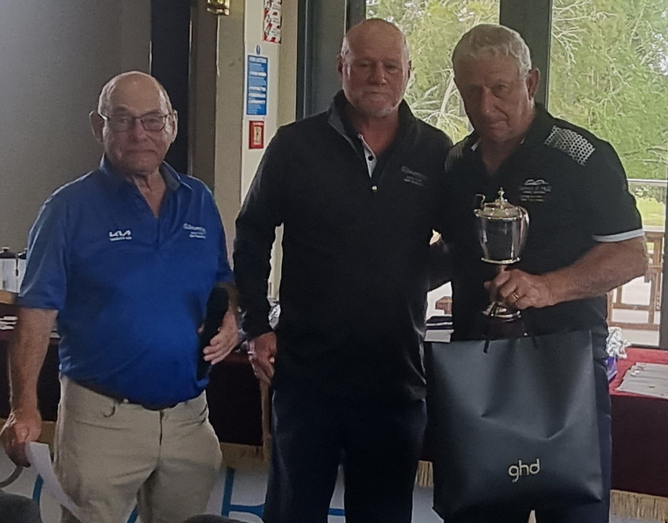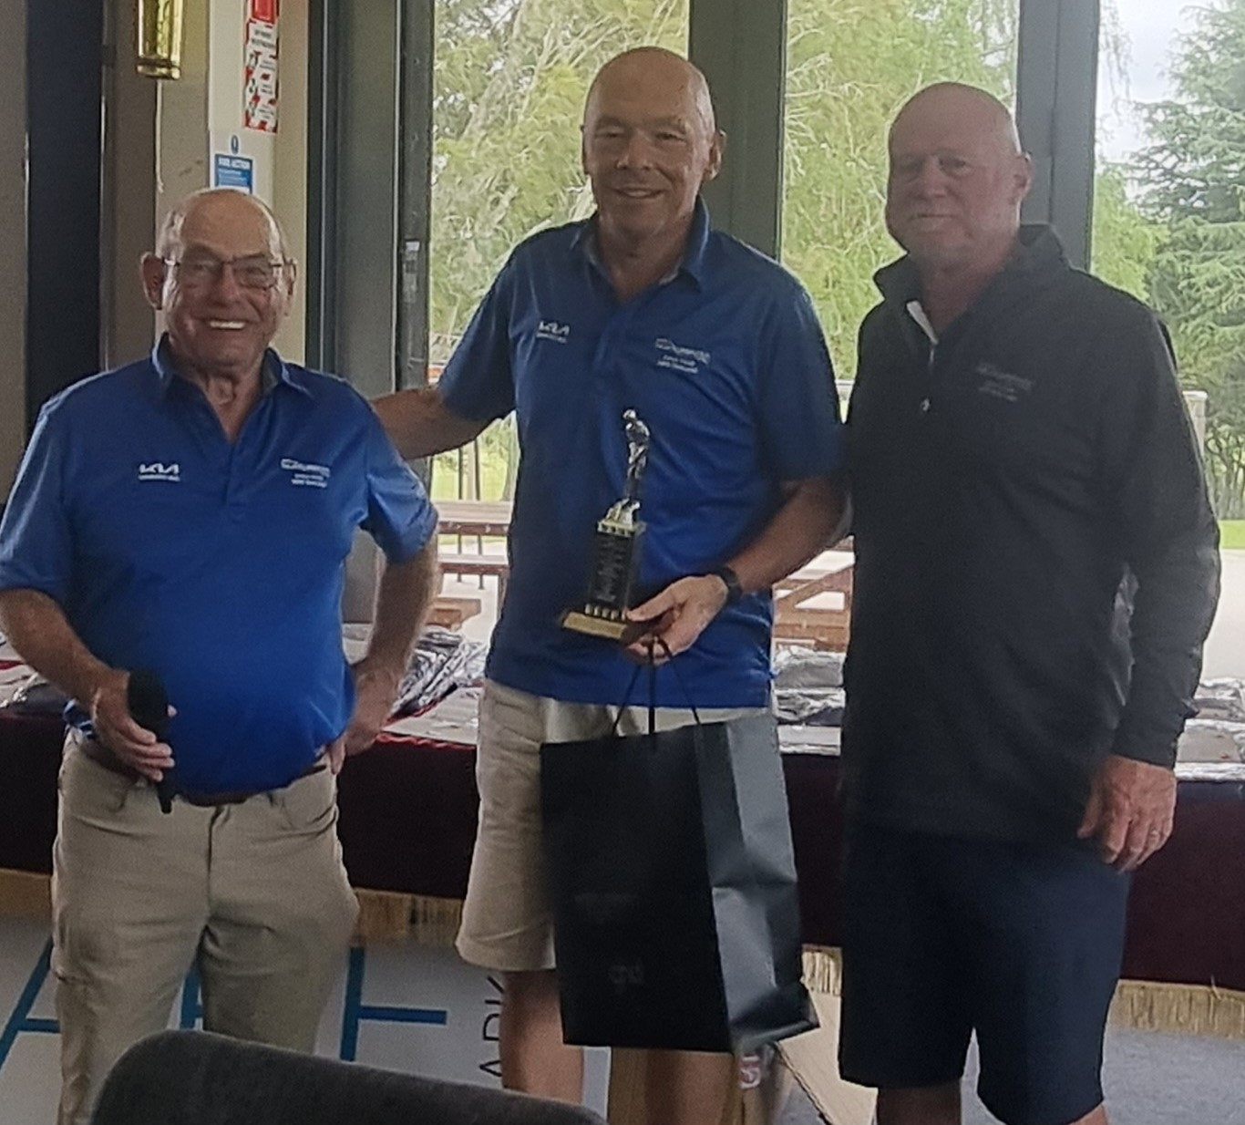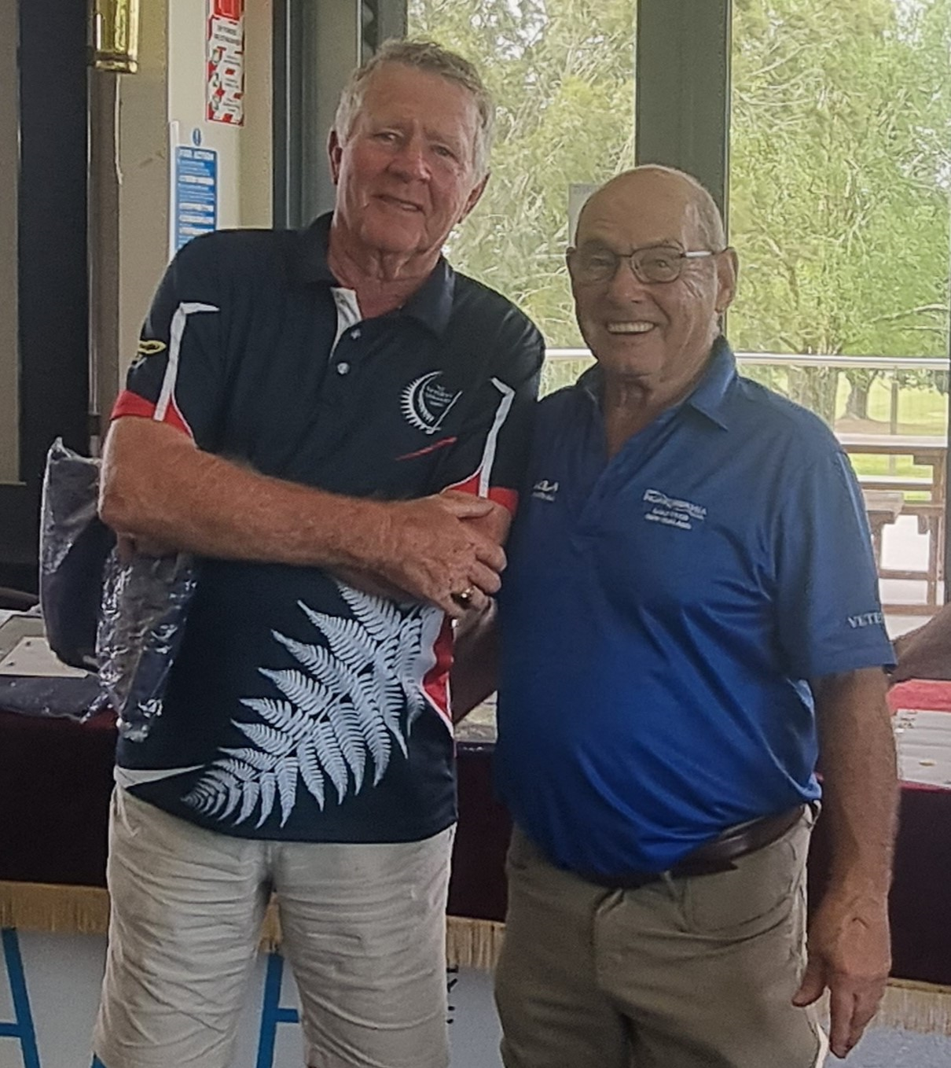

Terry Tapp Paul Barlow Barry Stenberg
Men Gross Winner Men Nett Winner Men Stableford Winner

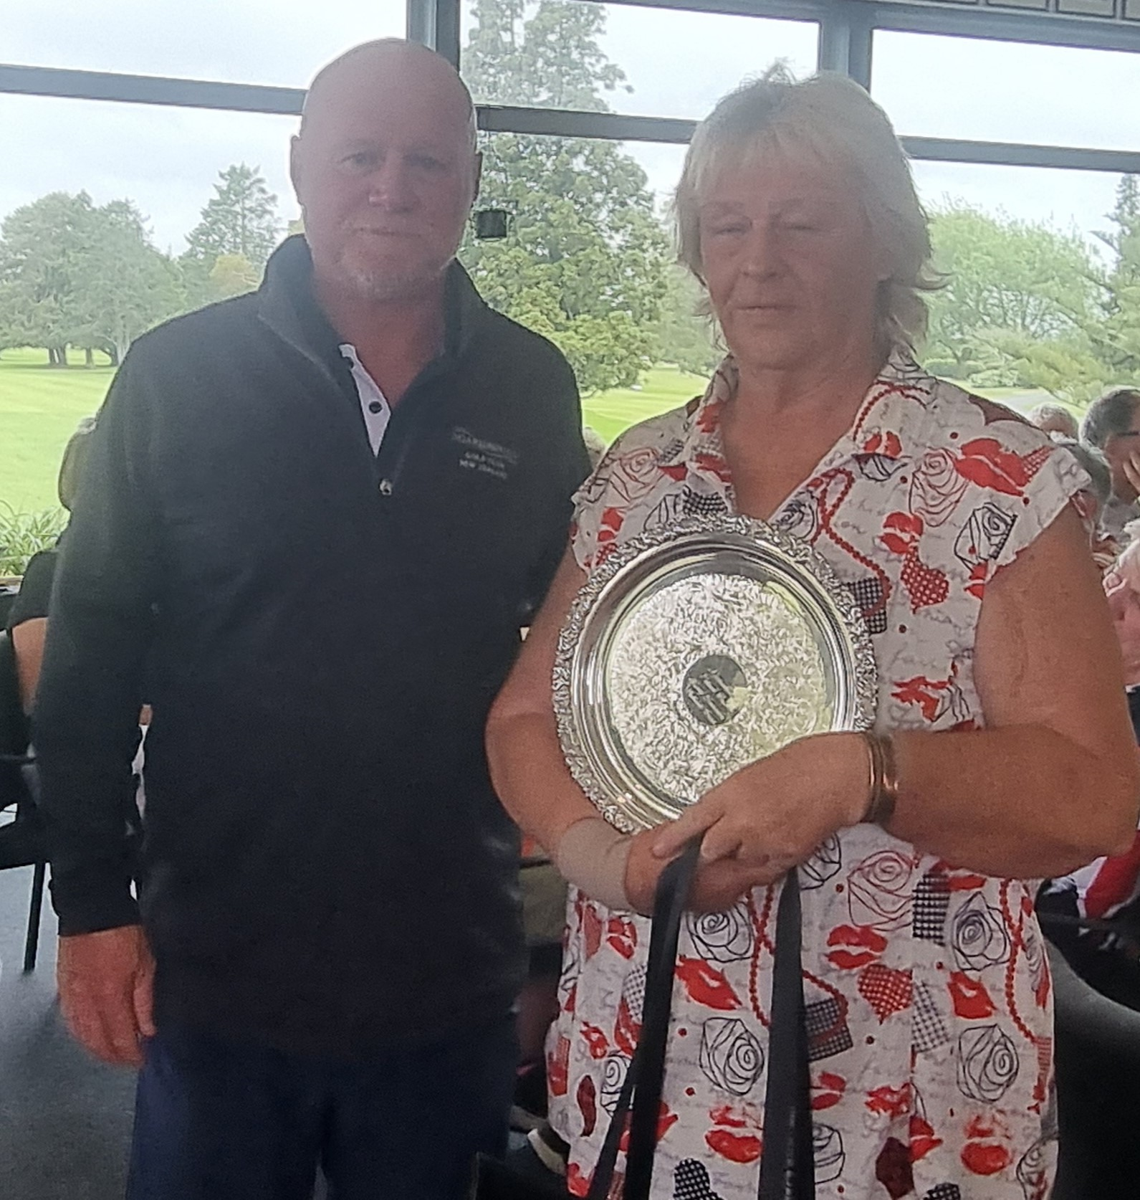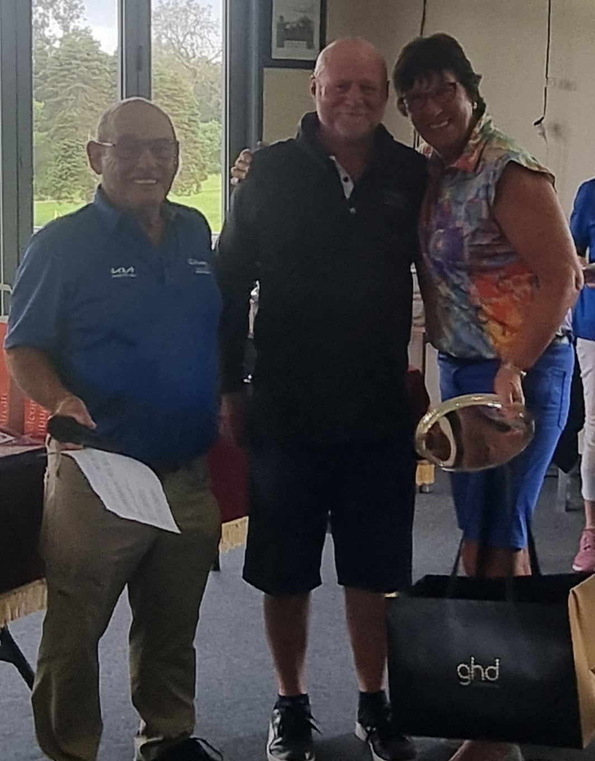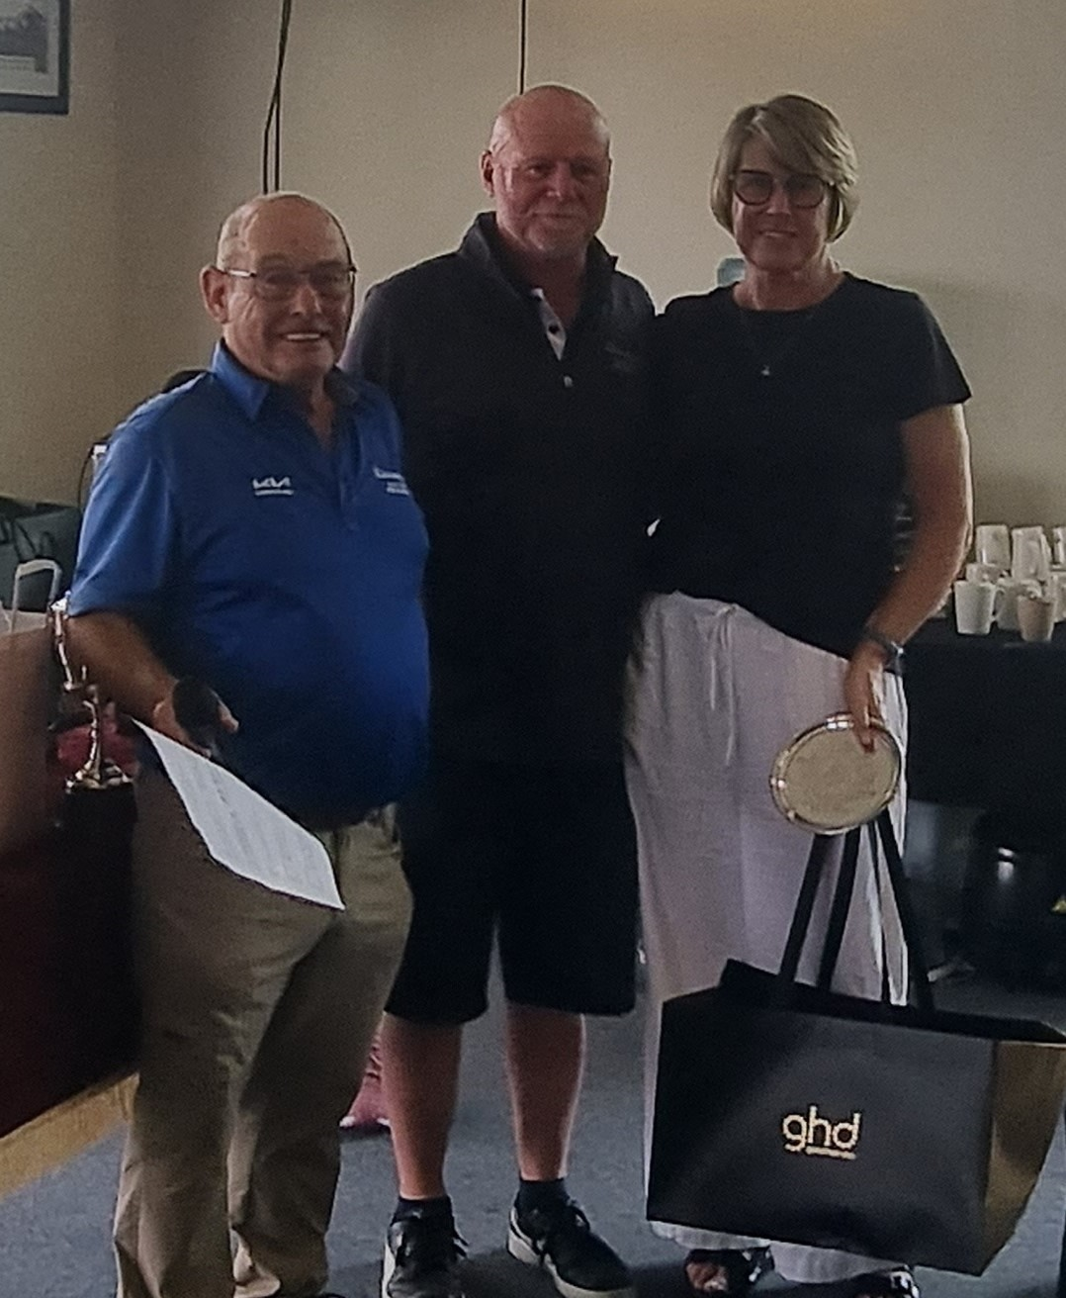

Raewyn T Moni Leslie Hatcher Karen Tapp
Women Gross Winner Women Nett Winner Women Stableford

